**SMARTBRIDGE DATA ANALYTICS EXTERNSHIP**

**PROJECT REPORT**

**TITLE:** “FINANCIAL ANALYSIS OF BANKS USING TABLEAU”

**TEAM MEMBERS:**

1. **Name:** Mohnish Kumaar D

**Reg No:** 20BPS1152

**Campus:** VIT Chennai

**Email id:** [mohnishkumaar.d2020@vitstudent.ac.in](mailto:mohnishkumaar.d2020@vitstudent.ac.in)

1. **Name:** Athul Robert R B

**Reg No:** 20BCE1610

**Campus:** VIT Chennai

**Email id:** [athulrobert.rb2020@vitstudent.ac.in](mailto:athulrobert.rb2020@vitstudent.ac.in)

1. **Name:** Jasjyot Singh

**Reg No:** 20BCE0748

**Campus:** VIT Vellore

**Email id:** [jasjyot.singh2020@vitstudent.ac.in](mailto:jasjyot.singh2020@vitstudent.ac.in)

1. **Name:** Akriti Bhardwaj

**Reg No:** 20BCE10824

**Campus:** VIT Bhopal

**Email id:** [akriti.bhardwaj2020@vitbhopal.ac.in](mailto:akriti.bhardwaj2020@vitbhopal.ac.in)

1. **INTRODUCTION:**

**1.1. Overview:**

The Financial Analysis of Bank project aims to leverage Tableau's data analytics capabilities to gain insights into the performance and rankings of banks based on their total assets. The dataset consists of columns such as Rank, Bank, Country, and Total Assets. By utilizing Tableau's visualization features, this project will provide a comprehensive overview of the financial landscape in the banking industry. It will enable stakeholders to identify trends, patterns, and outliers, facilitating informed decision-making and strategic planning. With intuitive visualizations and interactive dashboards, the project will present a clear picture of the bank rankings and their respective total assets, allowing for in-depth analysis and comparisons.

**1.2. Purpose:**

The purpose of the Financial Analysis of Bank project using Tableau is to enable effective financial analysis and decision-making in the banking industry. By utilizing the dataset's information on bank ranks, total assets, country, and bank names, this project will provide valuable insights into the performance and competitiveness of banks across different countries. Through interactive visualizations and dashboards, stakeholders can gain a deeper understanding of the financial health and market position of individual banks, identify high-performing institutions, and detect emerging trends. Furthermore, this project will aid in benchmarking and strategic planning, allowing banks to optimize their operations, attract investors, and enhance their overall financial performance.

1. **LITERATURE SURVEY:**

**2.1. Existing Methods to Solve:**

Existing methods or approaches to solve the problem of financial analysis in the banking industry typically involve traditional spreadsheet-based tools or custom-built analytical models. These methods often require manual data manipulation and lack the interactive and dynamic visualizations that Tableau offers.

Spreadsheets: Many financial analysts rely on spreadsheets like Microsoft Excel to analyze financial data. They manually input and manipulate data, perform calculations, and create static charts and graphs. However, this approach can be time-consuming, prone to errors, and lacks the dynamic visualizations and interactivity provided by Tableau.

Statistical Analysis Software: Analysts may use statistical analysis software like R or Python to perform more complex calculations and statistical modeling. While these tools offer advanced analytical capabilities, they often require programming skills and lack the intuitive visual interface of Tableau.

Custom-built models: Some organizations develop custom-built analytical models using programming languages or specialized software. These models can be tailored to specific financial analysis needs but often require significant resources and expertise for development and maintenance.

Tableau provides a user-friendly and intuitive platform for financial analysis. With its drag-and-drop functionality, interactive visualizations, and real-time data connections, Tableau enables analysts to explore, visualize, and gain insights from the banking dataset efficiently. It simplifies complex data analysis tasks, eliminates manual data manipulation, and empowers users to create dynamic and interactive dashboards for better decision-making.

**2.2. Proposed Solution:**

The proposed solution for financial analysis of banks using Tableau offers several advantages over traditional methods. With Tableau's robust data analytics capabilities and visualization tools, the solution aims to streamline the analysis process and provide comprehensive insights into bank performance.

Data Visualization: Tableau allows for the creation of interactive and visually appealing dashboards, charts, and graphs that enable users to explore the dataset effectively. Users can visualize the rankings, total assets, and other relevant metrics in a dynamic and intuitive manner, making it easier to identify trends, patterns, and outliers.

Real-time Data Connectivity: Tableau can connect to live data sources, ensuring that the analysis is based on the most up-to-date information. This feature enables users to monitor the financial performance of banks in real-time, facilitating timely decision-making and enhancing responsiveness.

Drill-down Capabilities: Tableau allows users to drill down into the data to examine details at different levels of granularity. Analysts can dive deeper into specific banks, countries, or subsets of data to gain a more thorough understanding of their financial performance.

Collaboration and Sharing: Tableau provides options for collaboration and sharing of analysis results. Users can collaborate with team members, share dashboards and reports, and enable stakeholders to interact with the data, fostering a collaborative and data-driven decision-making culture.

Overall, the proposed solution leverages Tableau's strengths in data visualization, real-time connectivity, drill-down capabilities, and collaboration to provide a comprehensive and user-friendly platform for financial analysis of banks.

1. **PROBLEM STATEMENT:**

As a data analyst, the problem at hand is to analyze the provided Excel sheet containing information about various banks, including their names, countries, total assets, and corresponding dates when the total assets were recorded. The objective is to gain insights from the data and propose a solution to address a specific challenge.

**3.1 Proposed solution:**

The proposed solution aims to analyze the provided data to identify the banks with the highest growth rate in terms of total assets over time. By doing so, we can determine the banks that have experienced significant expansion and potentially uncover factors contributing to their success. This analysis can be helpful for various stakeholders, such as investors, regulators, or researchers, who are interested in understanding the performance and trends within the banking industry.

To implement this solution, the following steps can be taken:

Data Preparation: Clean the Excel sheet data by removing any duplicates, missing values, or inconsistencies. Ensure that the dates are in a standardized format and the total assets are in a consistent currency.

Calculation of Growth Rate: Calculate the growth rate of each bank's total assets by comparing the recorded values over time. The growth rate can be determined using the following formula:

Identify Top Banks: Rank the banks based on their growth rates and identify the top performers. This can be done by sorting the data in descending order of growth rates and selecting the banks with the highest values.

Explore Factors: Investigate possible factors contributing to the success of the top-performing banks. This may involve additional data analysis, such as examining macroeconomic indicators, regulatory changes, or market conditions within the respective countries where the banks operate.

Visualization and Reporting: Create visualizations, such as line charts or bar graphs, to present the growth rates of the top banks over time. Generate a comprehensive report summarizing the findings, including insights into the contributing factors, and provide recommendations for stakeholders based on the analysis.

By implementing this proposed solution, stakeholders can gain valuable insights into the growth patterns of banks, identify successful institutions, and potentially uncover strategies that have contributed to their growth. This analysis can assist in making informed investment decisions, evaluating regulatory policies, and further research in the banking sector.

1. **THEORETICAL ANALYSIS:**

**4.1. Block Diagram:**

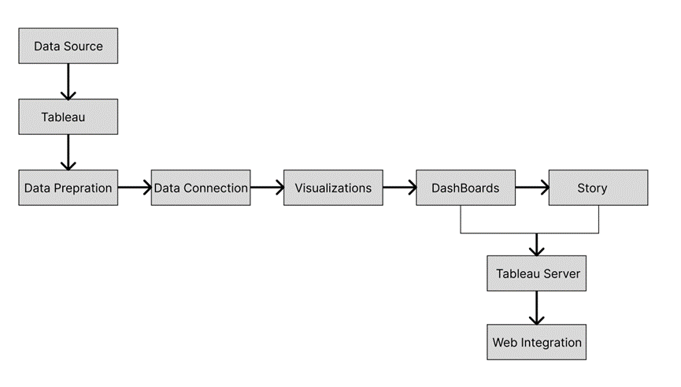

**4.2. Hardware and Software Requirements:**

The hardware and software requirements for the financial analysis project using Tableau and Flask integration are as follows:

Hardware Requirements:

A computer or server capable of running Tableau and Flask smoothly, with sufficient processing power and memory.

Adequate storage capacity to store the dataset, Tableau workbooks, and Flask web application files.

Reliable internet connectivity to access Tableau Server and host the Flask web app.

Software Requirements:

Tableau Desktop: The software tool used for data visualization and analysis.

Tableau Server: Required to publish and host the Tableau dashboards and story for web access.

Flask: A Python web framework used to develop the web application for integrating Tableau dashboards and story.

Python: The programming language used for developing the Flask web app.

Database Management System (DBMS): If the dataset is stored in a database, a compatible DBMS is needed to establish the connection.

Additionally, it is essential to ensure that the software versions are compatible and up to date to avoid any compatibility issues between Tableau, Flask, Python, and the supporting libraries or dependencies used in the project.

1. **EXPERIMENTAL INVESTIGATIONS:**

During the analysis phase of this project, several investigations were conducted to gain meaningful insights into the financial data of banks using Tableau. The data was thoroughly examined, exploring various dimensions such as bank rankings, total assets, and geographical distribution. Key metrics and patterns were identified through interactive visualizations, enabling a deeper understanding of the financial performance across different countries and banks. Comparative analysis was performed to uncover outliers and identify top-performing institutions. Additionally, data drill-down capabilities allowed for detailed exploration of specific banks, facilitating in-depth investigation into their financial health. The analysis phase provided valuable insights and laid the foundation for the development of comprehensive and insightful dashboards and reports.

1. **FLOWCHART:**

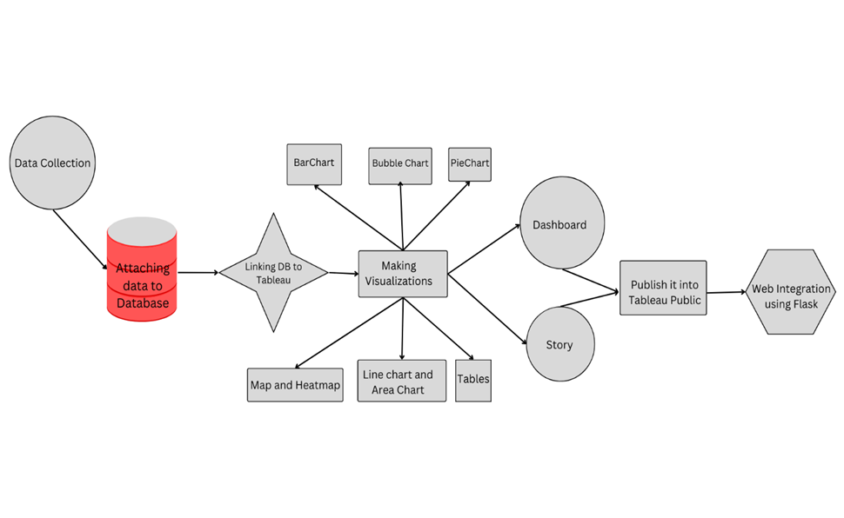

1. **RESULT:**

We have performed various data visualizations and created a dashboard and story using Tableau. And also , we have integrated the dashboard and story into a web application using Flask. Here are the results of our analysis:

* Bar Chart - Sum of Total Assets by Bank (Filtered by Top 10 Banks)

This chart displays the total assets of the top 10 banks in descending order. It provides a visual representation of the comparative sizes of the banks based on their total assets.

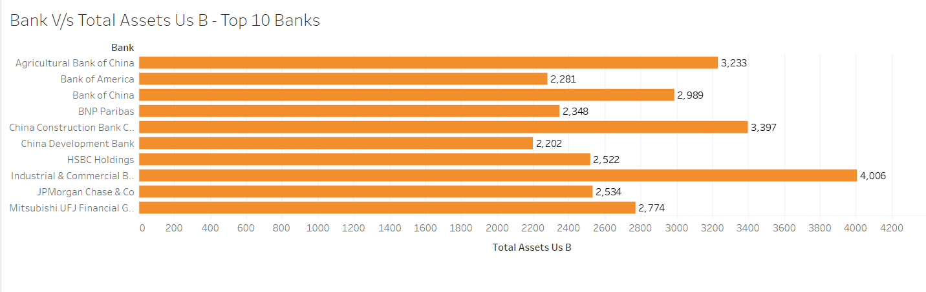

* Bubble Chart - Banks vs. Total Assets (Filtered by Top 5 Banks)

This chart shows each bank as a bubble, with the size of the bubble representing the total assets of the bank. It helps visualize the distribution of assets across the top 5 banks.

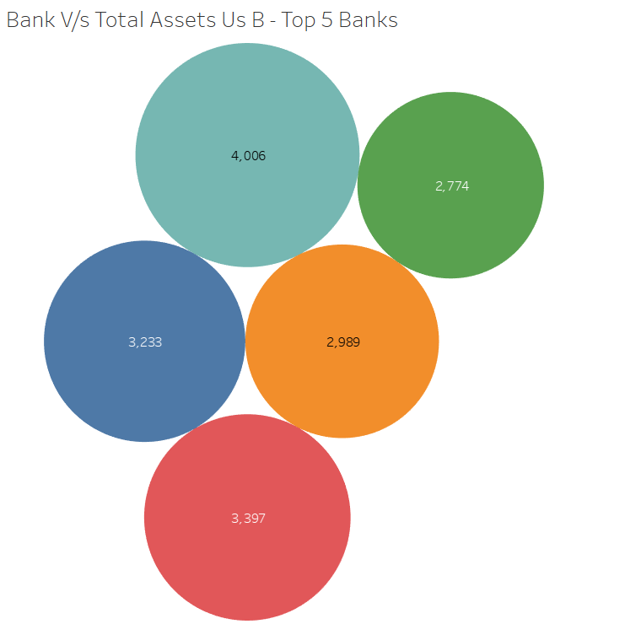

* Pie Chart - Country vs. Number of Banks

This chart presents the number of banks in each country as a proportion of the whole. It allows you to quickly understand the distribution of banks across different countries.

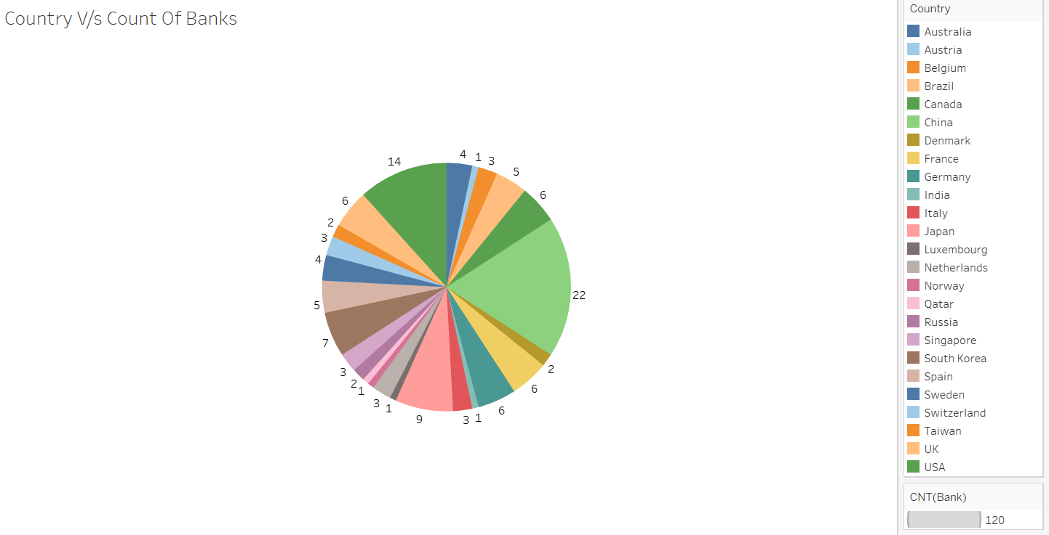

* World Map - Country vs. Number of Banks

This visualization provides a geographical representation of the number of banks in each country. It gives an overview of the global distribution of banks.

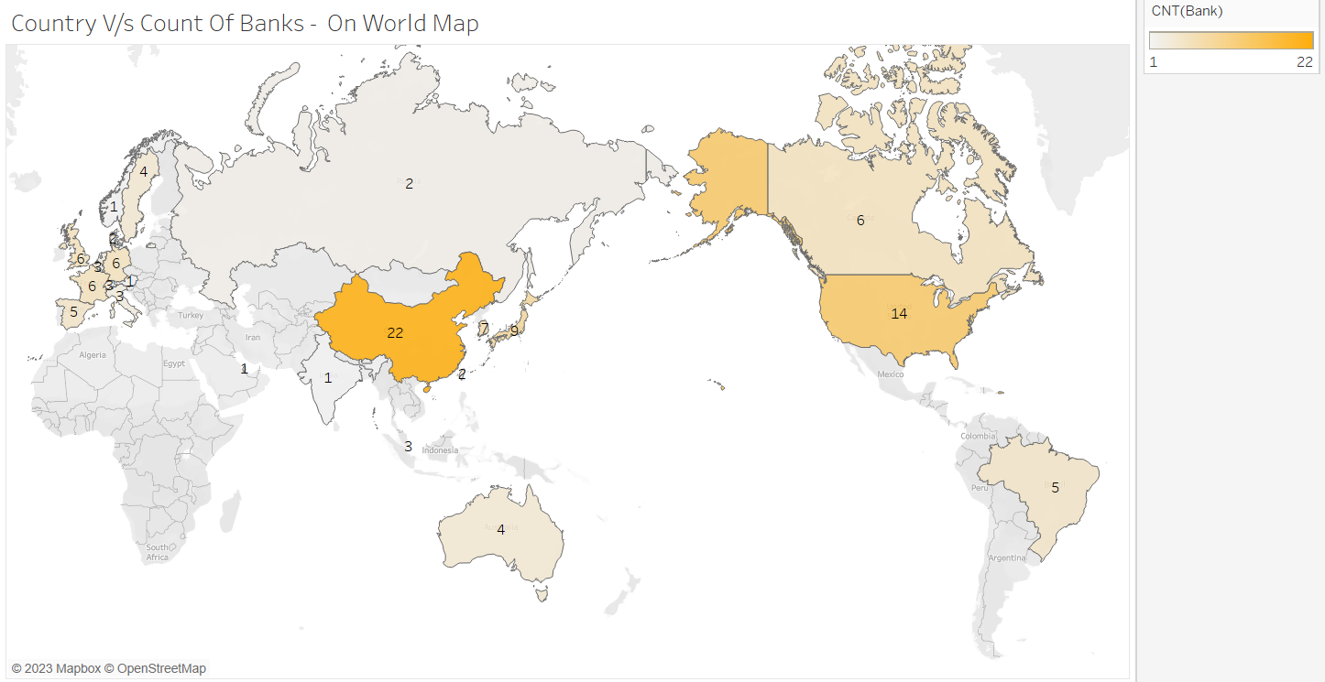

* Treemaps - Banks vs. Total Assets (Filtered by Banks of France)

These treemaps display the total assets of banks in France, visually presenting the relative sizes of each bank based on its assets.

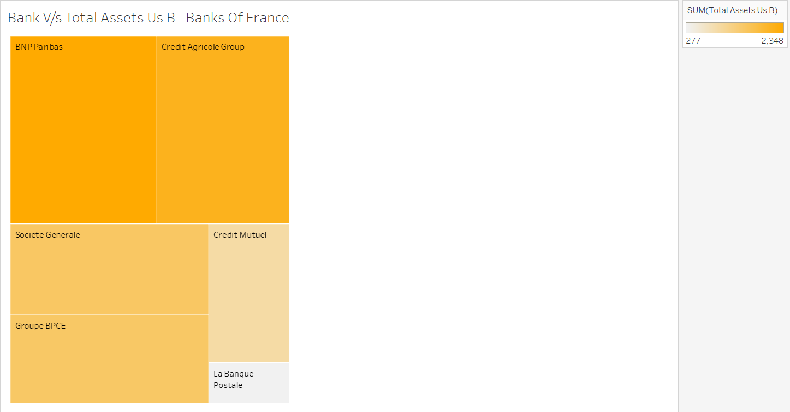

* Line Chart - Year of Balance Sheet vs. Total Assets

This chart depicts the trend of total assets over time, showing the changes in assets for each year.

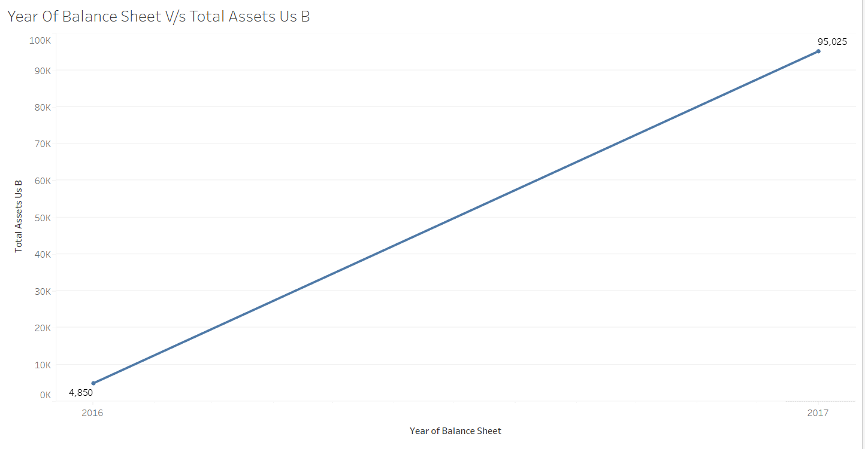

* Table - Banks vs. Balance Sheet per Year

This table presents the balance sheet information for each bank, organized by year. It allows for a detailed examination of the assets for each bank in different years.

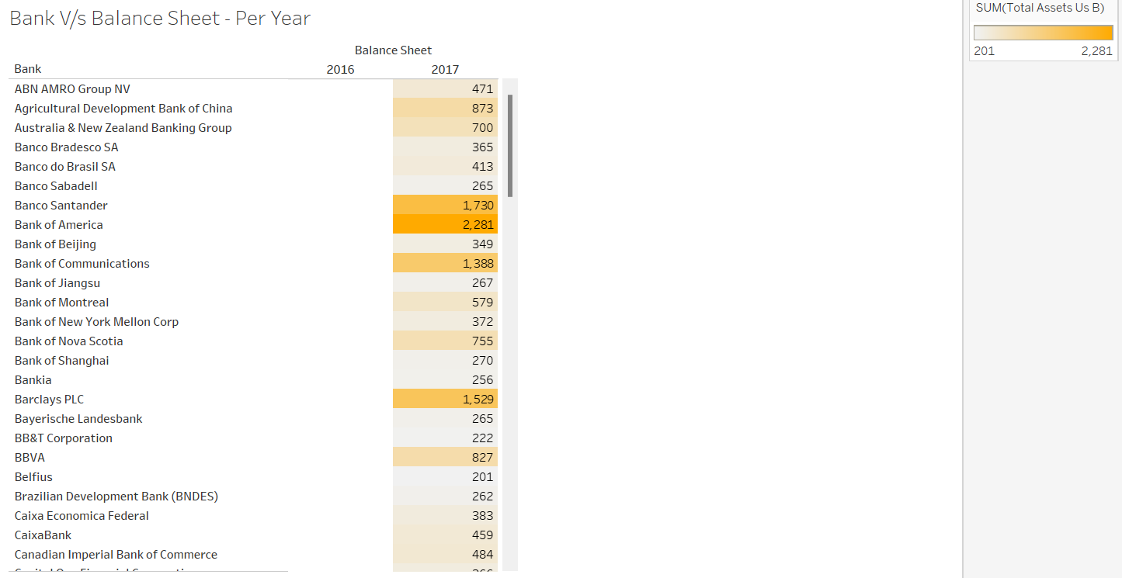

* Area Chart - Country/Bank vs. Total Assets (Filtered by Top 10 Banks)

This chart provides a stacked area representation of the total assets for each country and bank combination. It helps understand the distribution of assets among the top 10 banks across different countries.

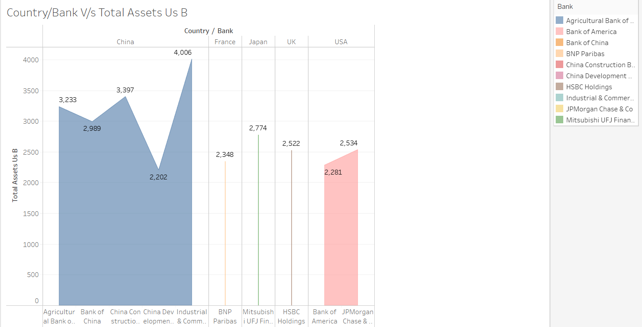

* Table - Banks vs. Total Assets per Month

This table displays the total assets of banks on a monthly basis. It offers a detailed breakdown of assets for each bank.

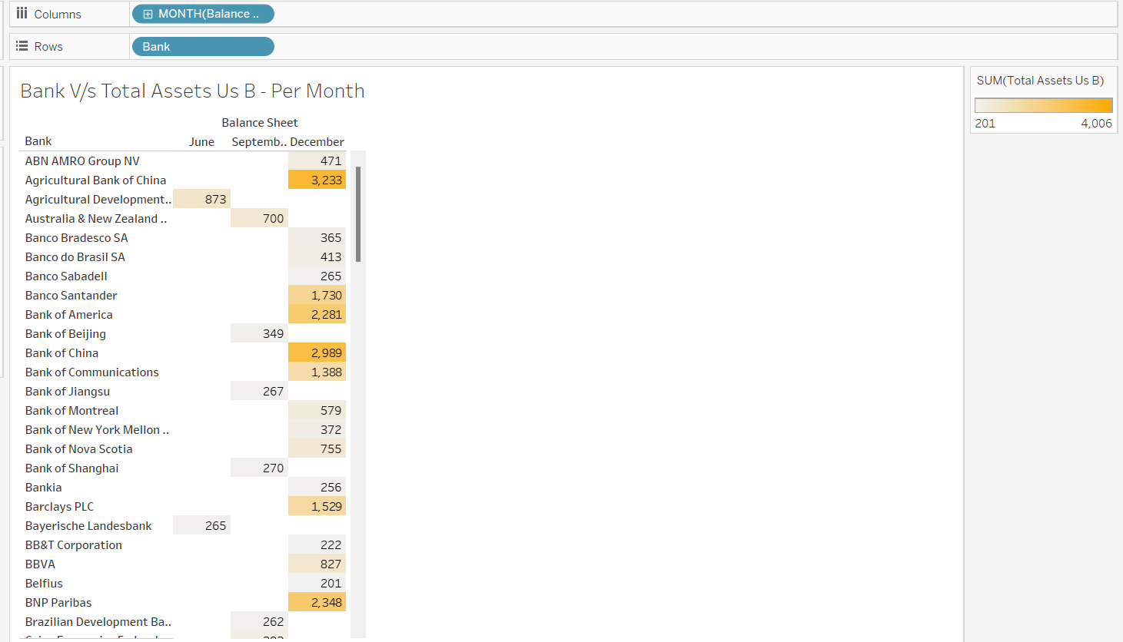

* Table - Country vs. Average Total Assets

This table presents the average total assets for each country, allowing for a comparison of asset levels across different countries.

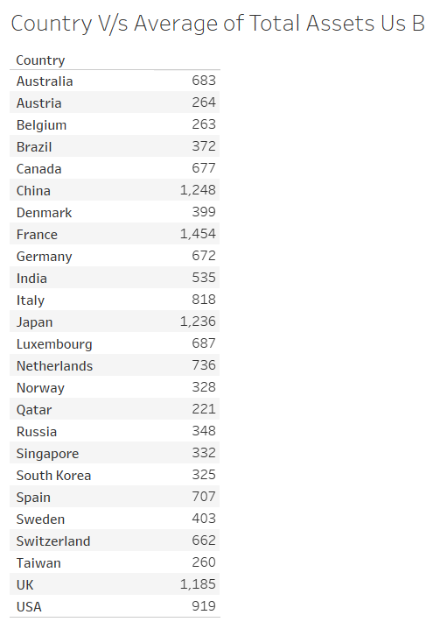

We have created a dashboard and a story with the visualizations, which we have published on Tableau Public.

Dashboard 1:

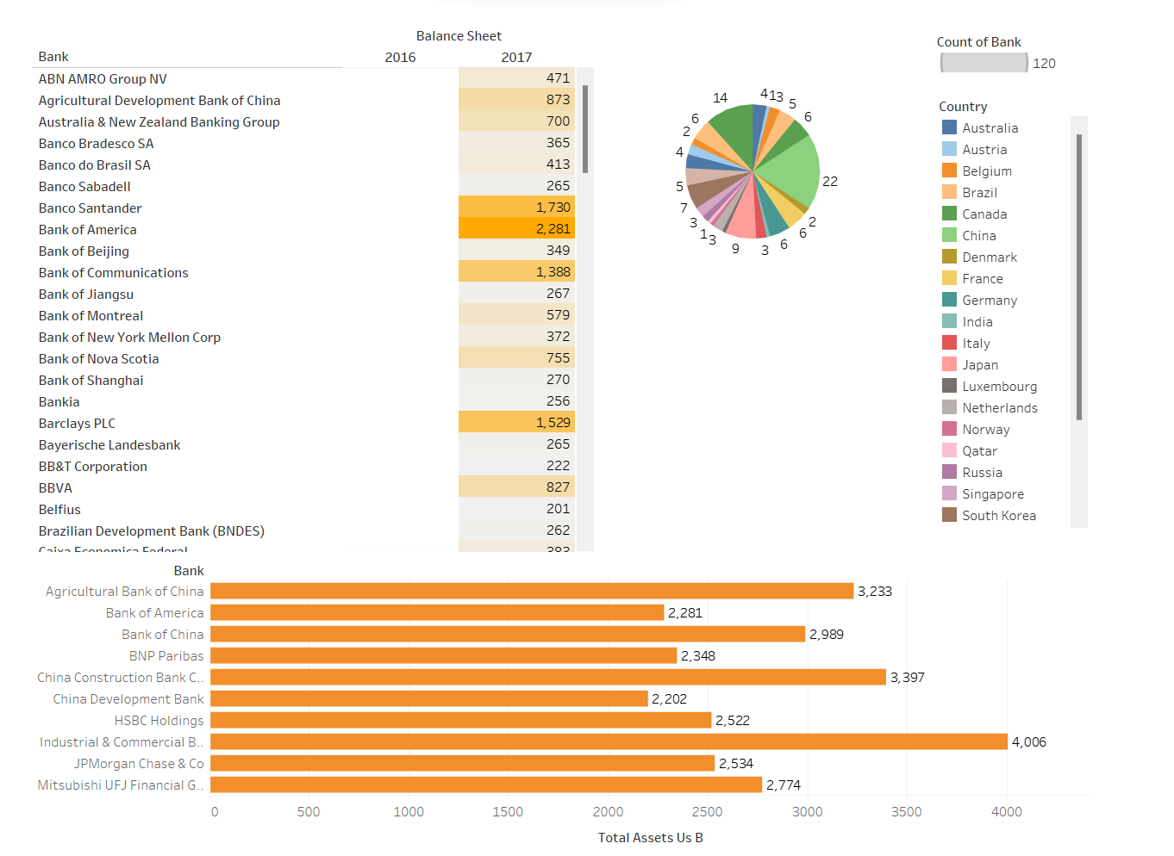

Dashboard 2:

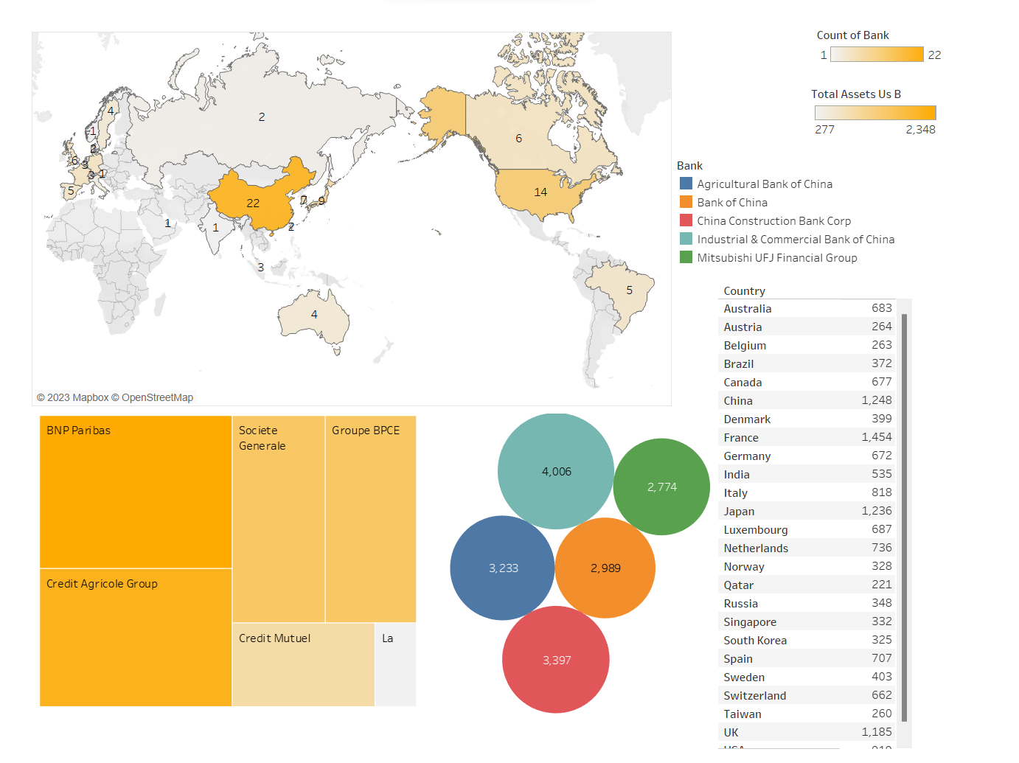

Dashboard 3:

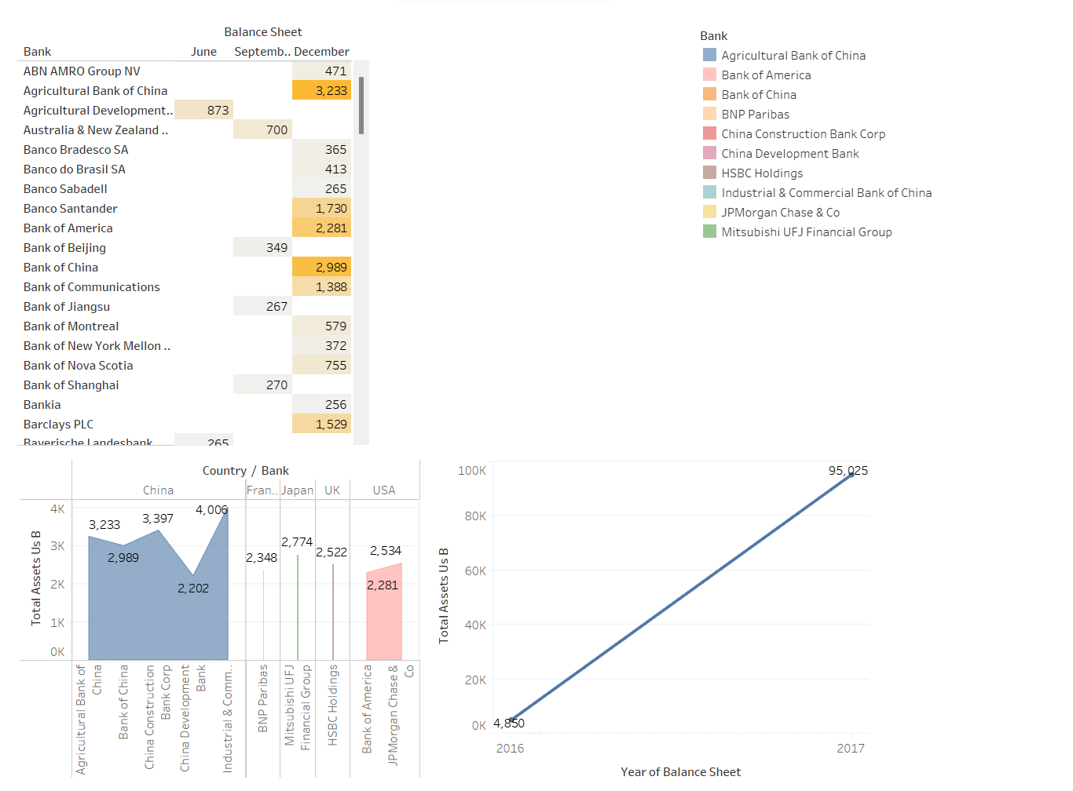

Furthermore, We have integrated the dashboard and story into a web application using Flask, providing web-based access to the data and insights that we have generated.

**Web Integration:**

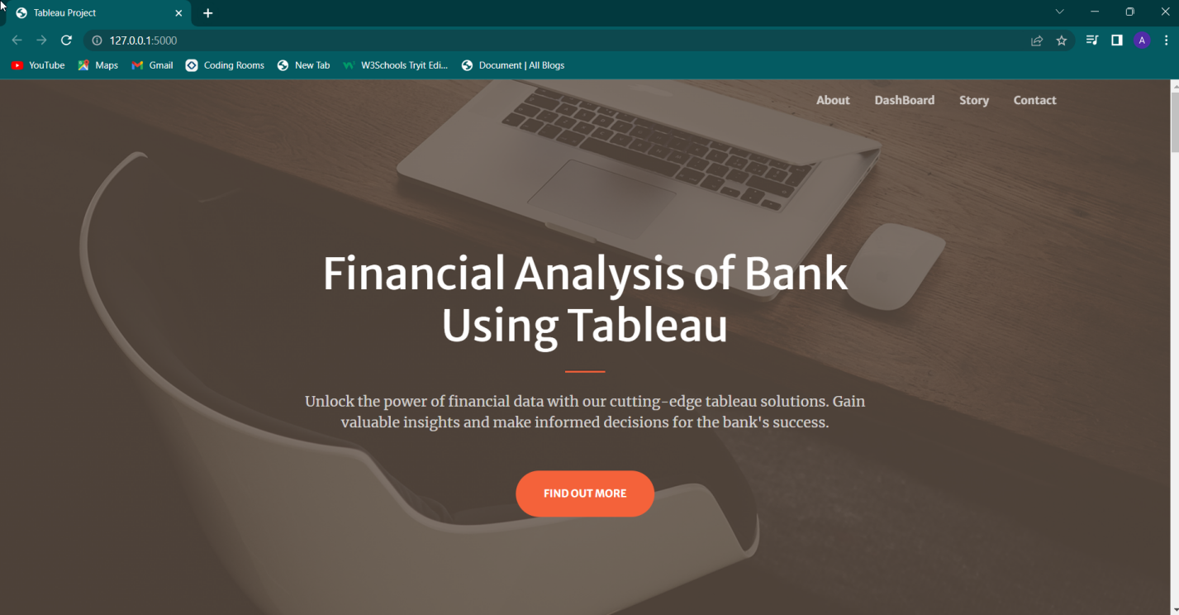

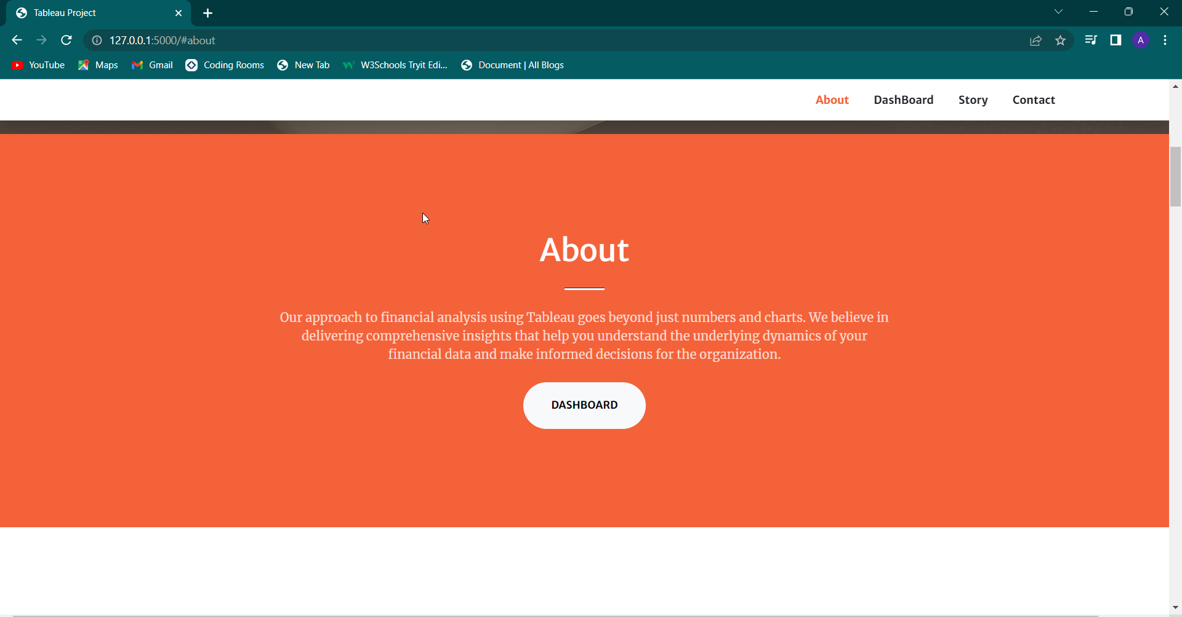

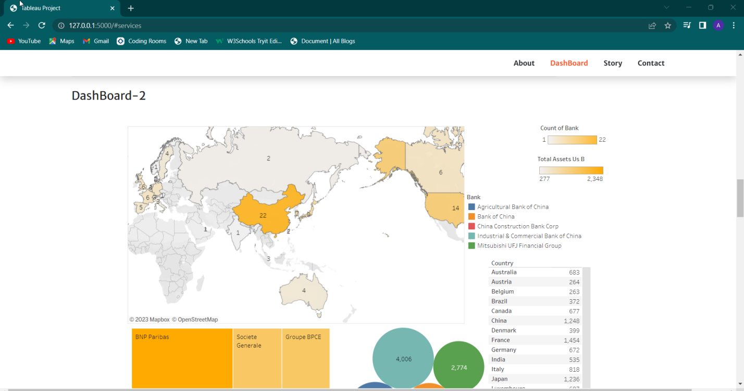

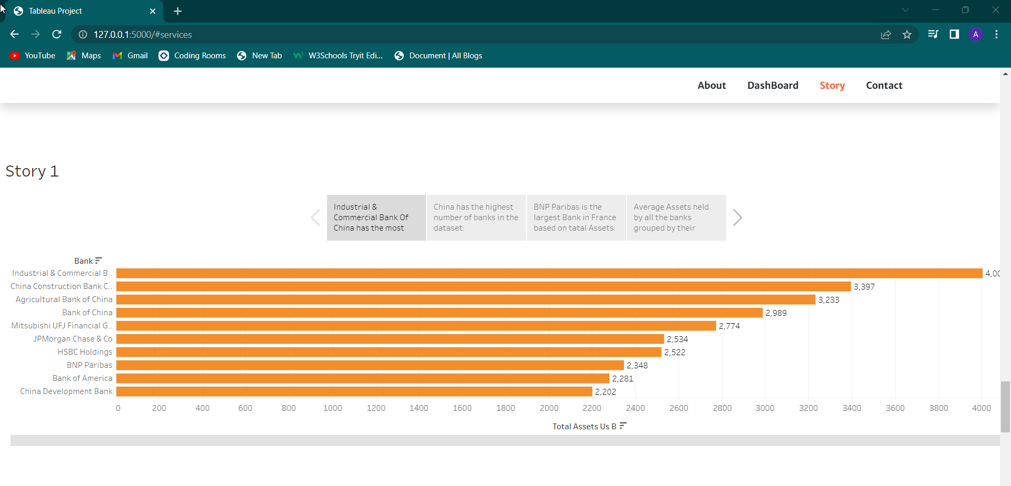

1. **VIDEO EXPLANATION**

**(1) Connection**

[**https://drive.google.com/file/d/1nWL3dURh1YEm9__1vOEokm_HVE7iETJE/view?usp=drive_link**](https://drive.google.com/file/d/1nWL3dURh1YEm9__1vOEokm_HVE7iETJE/view?usp=drive_link)

**(2)Bank Vs Total Assets of top 10 Banks**

[**https://drive.google.com/file/d/1OmtRl37bBoLPzGhM8ptQVrRZ3HrhIcS0/view?usp=sharing**](https://drive.google.com/file/d/1OmtRl37bBoLPzGhM8ptQVrRZ3HrhIcS0/view?usp=sharing)

**(3)Bank vs Total Assets of top 5 Banks**

[**https://drive.google.com/file/d/1XP0hIt9m989pbuIkgg_iQZGEv7Y8SkNz/view?usp=sharing**](https://drive.google.com/file/d/1XP0hIt9m989pbuIkgg_iQZGEv7Y8SkNz/view?usp=sharing)

**(4) Country Vs Count of Banks**

[**https://drive.google.com/file/d/1u8gHVsUSHvsyidDBoJP7mFQkLp023Xjm/view?usp=sharing**](https://drive.google.com/file/d/1u8gHVsUSHvsyidDBoJP7mFQkLp023Xjm/view?usp=sharing)

**(5) Country Vs Count of Banks - On world map**

[**https://drive.google.com/file/d/1MXsdJ0tgZDCL4iLe5pwjdHW94A2UfS3t/view?usp=sharing**](https://drive.google.com/file/d/1MXsdJ0tgZDCL4iLe5pwjdHW94A2UfS3t/view?usp=sharing)

**(6) Bank Vs Total Assets Us B - Banks of France**

[**https://drive.google.com/file/d/1fhggdBRuvNuMfprpeUnL2qYZZupOtish/view?usp=sharing**](https://drive.google.com/file/d/1fhggdBRuvNuMfprpeUnL2qYZZupOtish/view?usp=sharing)

**(7) Year of Balance sheet Vs Total assets Us B**

[**https://drive.google.com/file/d/1eJAjqAlTCTkgxoOgioah63N6Orze896O/view?usp=sharing**](https://drive.google.com/file/d/1eJAjqAlTCTkgxoOgioah63N6Orze896O/view?usp=sharing)

**(8) Bank Vs Balance sheet - per year**

[**https://drive.google.com/file/d/1hUX8bOVNz-BUBj_Ez7zrqenxF7zAyVgm/view?usp=sharing**](https://drive.google.com/file/d/1hUX8bOVNz-BUBj_Ez7zrqenxF7zAyVgm/view?usp=sharing)

**(9) Country/Bank Vs Total Assets Us B**

[**https://drive.google.com/file/d/1AzFrNxNWUMkpccjsa9q8cet8HXxOe3-o/view?usp=drive_link**](https://drive.google.com/file/d/1AzFrNxNWUMkpccjsa9q8cet8HXxOe3-o/view?usp=drive_link)

**(10) Bank Vs Total Assets Us B per Month**

[**https://drive.google.com/file/d/1MZppYoPDsCTkQe8VULsLLm_7ieYIlTzp/view?usp=drive_link**](https://drive.google.com/file/d/1MZppYoPDsCTkQe8VULsLLm_7ieYIlTzp/view?usp=drive_link)

**(11) Country Vs Average of Total Assets Us B**

[**https://drive.google.com/file/d/16-9qidIVIu4DHn-p4VQi6MCKtsb6sKvp/view?usp=drive_link**](https://drive.google.com/file/d/16-9qidIVIu4DHn-p4VQi6MCKtsb6sKvp/view?usp=drive_link)

**(12) Dashboard 1**

[**https://drive.google.com/file/d/1lFY6R7gjkh4FjCUJ2a5_tg0cDjt8R68Z/view?usp=drive_link**](https://drive.google.com/file/d/1lFY6R7gjkh4FjCUJ2a5_tg0cDjt8R68Z/view?usp=drive_link)

**(13) Dashboard 2**

[**https://drive.google.com/file/d/1ASF4JzcsX8tvxXX4vZzGM3nhcgIXEsht/view?usp=drive_link**](https://drive.google.com/file/d/1ASF4JzcsX8tvxXX4vZzGM3nhcgIXEsht/view?usp=drive_link)

**(14) Dashboard 3**

[**https://drive.google.com/file/d/1JPbvxMi8-q9mAw7MC3y4iGMad-lnIo8b/view?usp=drive_link**](https://drive.google.com/file/d/1JPbvxMi8-q9mAw7MC3y4iGMad-lnIo8b/view?usp=drive_link)

**(15) Story**

[**https://drive.google.com/file/d/1JPbvxMi8-q9mAw7MC3y4iGMad-lnIo8b/view?usp=drive_link**](https://drive.google.com/file/d/1JPbvxMi8-q9mAw7MC3y4iGMad-lnIo8b/view?usp=drive_link)

**(16) Web Integration**

[**https://drive.google.com/file/d/1dQGZ629l4WZxwvsXVA8NMj8trPqFT25_/view?usp=sharing**](https://drive.google.com/file/d/1dQGZ629l4WZxwvsXVA8NMj8trPqFT25_/view?usp=sharing)

1. **ADVANTAGES & DISADVANTAGES:**

Advantages:

* Data Visualization: Tableau enables interactive and visually appealing dashboards, making it easier to identify trends and patterns.
* Real-time Data Connectivity: Tableau connects to live data sources, allowing for timely decision-making based on up-to-date information.
* Drill-down Capabilities: Analysts can examine data at different levels of detail, gaining a thorough understanding of bank performance.
* Collaboration and Sharing: Tableau facilitates collaboration and sharing of analysis results, fostering a data-driven decision-making culture.

Disadvantages:

* Learning Curve: Tableau requires time and effort to learn and master its features.
* Cost: Tableau is a commercial software that may have licensing costs.
* Data Security: Proper measures must be taken to ensure data security when connecting to live data sources.
* Dependency on Data Quality: Accurate and reliable analysis depends on high-quality data.
* Scalability: Very complex analyses may require additional resources or optimization techniques.

1. **APPLICATIONS:**

The solution of using Tableau for financial analysis of banks has various applications across different areas. Some of the key areas where this solution can be applied include:

* Financial Institutions:
* Banks and financial institutions can use Tableau to analyze their own financial performance, compare it with industry benchmarks, and identify areas for improvement.
* Risk management teams can utilize Tableau to monitor and analyze key risk indicators, assess portfolio performance, and identify potential areas of concern.
* Investment and Portfolio Management:
* Investment firms and portfolio managers can use Tableau to analyze financial data of banks and make informed investment decisions.
* Portfolio performance can be tracked and evaluated through visualizations, helping to identify top-performing banks and potential investment opportunities.
* Financial Consulting:
* Financial consultants can use Tableau to provide data-driven insights to clients in the banking sector, supporting decision-making processes.
* Performance analysis, benchmarking, and scenario modeling can be conducted using Tableau's visualization capabilities.
* Academic Research and Education:
* Tableau can be utilized in academic research to analyze financial data of banks for research purposes.
* Educational institutions can incorporate Tableau in finance and banking courses to teach data analysis and visualization techniques using real-world financial data.
* Credit Risk Analysis:

Banks can employ Tableau to analyze credit risk metrics such as default rates,delinquencies, and loan portfolios to make informed lending decisions and manage credit risk exposure.

* Fraud Detection and Prevention:

Tableau's visualizations can aid in identifying patterns, anomalies, and potential fraudulent activities in financial data, helping banks enhance their fraud detection and prevention efforts.

* Investor Relations:

Tableau's visualizations can be used to create interactive investor relations dashboards,presenting financial metrics,key performance indicators, and market trends to shareholders and potential investors.

1. **CONCLUSION:**

* Bank Performance: Analyzing the total assets of each bank over time can provide insights into their financial performance. By comparing the growth or decline in assets, we can assess the stability and profitability of the banks. This information can be useful for investors, regulators, and policymakers.
* Country Comparison: Grouping the data by country can help identify trends and patterns in the banking sector of different countries. It allows us to compare the total assets and growth rates of banks within each country, providing a broader understanding of the financial landscape across nations.
* Identifying Key Players: Analyzing the data can help identify banks with significant assets and track their performance over time. This information is valuable for understanding the market dominance of certain banks and their impact on the overall financial sector.
* Risk Assessment: By examining the fluctuations in total assets, we can assess the risk associated with specific banks. Sudden drops or consistent decline in assets may indicate financial instability or potential risks within the bank.

1. **FUTURE SCOPE:**

* Financial Stability: Investigate factors that contribute to financial stability by considering additional variables such as liabilities, capital adequacy, and loan portfolios.
* Risk Analysis: Explore the correlation between economic indicators, regulatory policies, and bank asset fluctuations to better predict potential risks.
* Market Share Analysis: Analyze the market share of each bank based on their total assets and explore how it evolves over time.
* Comparative Studies: Conduct comparative studies across different sectors, such as commercial banks, investment banks, and credit unions, to identify industry-specific trends and performance metrics.

1. **BIBILIOGRAPHY:**

<https://blog.imarticus.org/technologies-for-financial-analysis-excel-power-bi-and-tableau/>

<https://www.softwebsolutions.com/resources/implement-tableau-for-financial-reporting.html>

<https://www.phdata.io/blog/corporate-finance-tableau-dashboard-example/>

<https://corporatefinanceinstitute.com/resources/business-intelligence/tableau-uses-in-finance/>

<https://www.youtube.com/watch?v=SgN7M28rrvw>